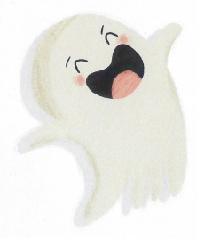
MY IMAGINARY FRIEND
Draw a picture of your imaginary friend. Is it a dragon, an animal, a ghost, an alien, a monster – or someone just like you?

What’s you imaginary friend’s name? _________________________________

What games do you play together? __________________________________
________________________________________________________________
Where does your imaginary friend live? ________________________________________________________________
How old is your imaginary friend? ____________________________________

© Ghostie (Windy Hollow Books), by Stephanie Owen Reeder and Mel Armstrong

