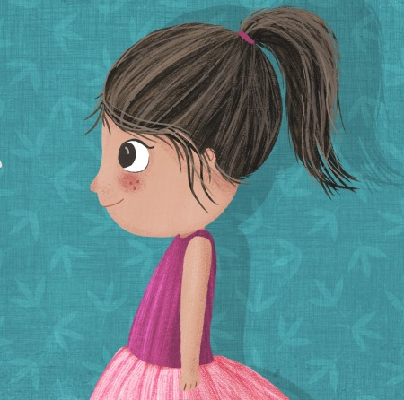
Help Ava
find Ghostie!

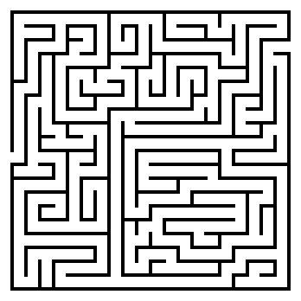
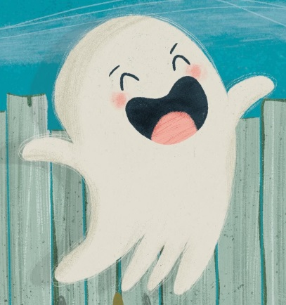

© Ghostie (Windy Hollow Books) by
Stephanie Owen Reeder and Mel Armstrong

