AVA AND GHOSTIE COLOURING-IN
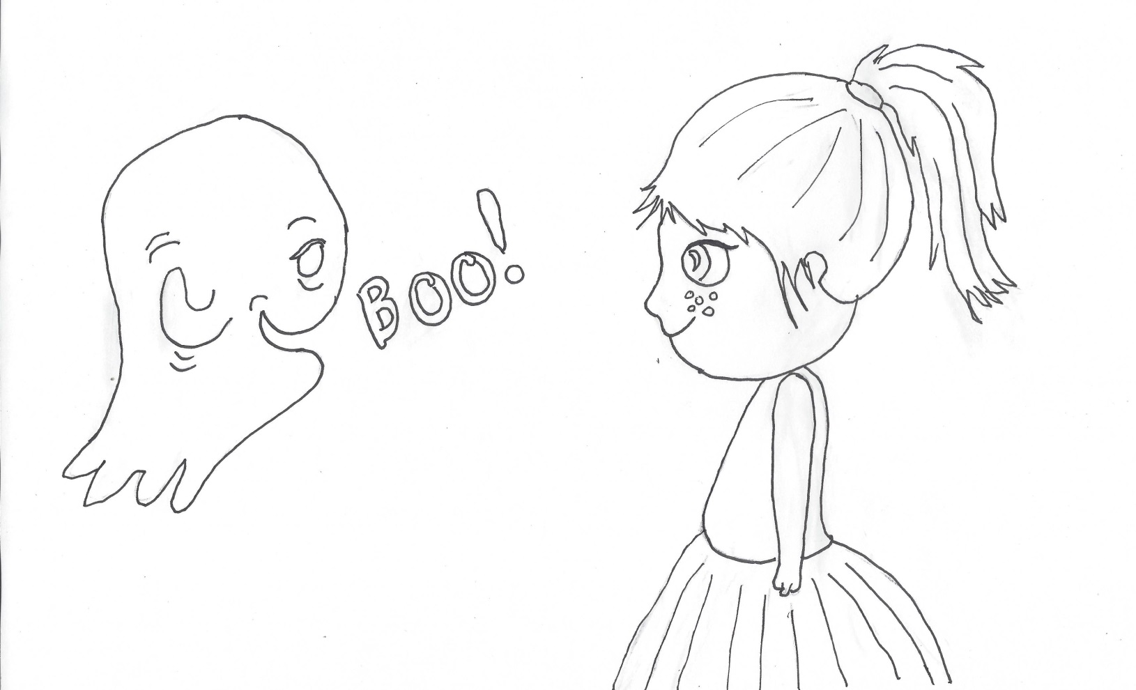
Design you own wallpaper background!
© Ghostie (Windy Hollow Books) by Stephanie Owen Reeder and Mel Armstrong

